Gauss seidel

Reading Matrix and Vector Input from File

Purpose: This function reads a square matrix A of size n x n and a vector b of size n from a specified file. It ensures the file is properly formatted and handles errors during input parsing.
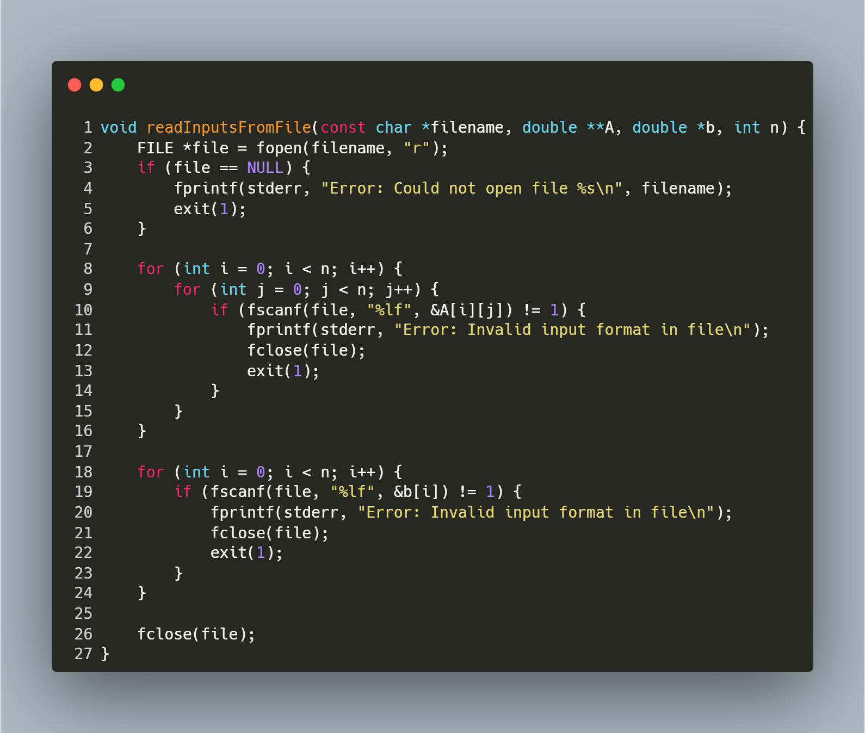
Step-by-Step Explanation
1. Open File
- FILE *file = fopen(filename, "r"); opens the file in read mode.
- If the file cannot be opened (e.g., it does not exist), the function prints an error message and exits with status 1.
2. Read Matrix A
- The nested loops iterate over each row (i) and column (j) of the matrix:
  - fscanf(file, "%lf", &A[i][j]) reads a floating-point number into A[i][j].
  - If the read operation fails (e.g., non-numeric data), the function prints an error, closes the file, and exits.
3. Read Vector b
- The loop iterates over each element of the vector:
  - fscanf(file, "%lf", &b[i]) reads a floating-point number into b[i].
  - If the read operation fails, the function prints an error, closes the file, and exits.
4. Close File
- fclose(file); closes the file after all data is read to release system resources.

function: Matrix-Vector Multiplication

Purpose: This function multiplies a square matrix A of size n x n with a vector b of size n and returns the resulting vector. It computes the dot product of each row of A with b.
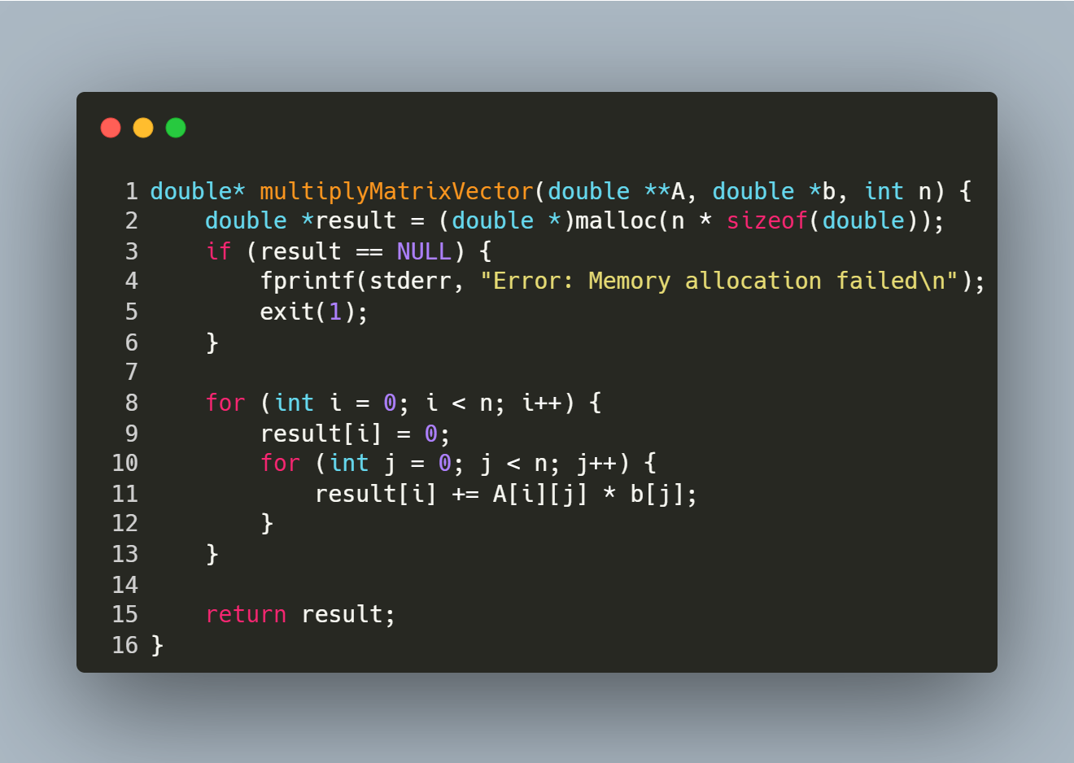
Step-by-Step Explanation
- Memory Allocation:
  - Allocates memory for the result vector result of size n.
  - Exits with an error if memory allocation fails.
- Row Iteration:
  - The outer loop iterates over each row i of the matrix A.
- Dot Product Calculation:
  - Initializes result[i] to 0.
  - The inner loop iterates over each column j of the matrix.
  - Computes the dot product of the i-th row of A and the vector b.
- Return Result:
  - Returns the computed vector result.

function: Vector Subtraction

Purpose: This function computes the element-wise subtraction of two vectors v1 and v2 of size n and returns the result as a new vector
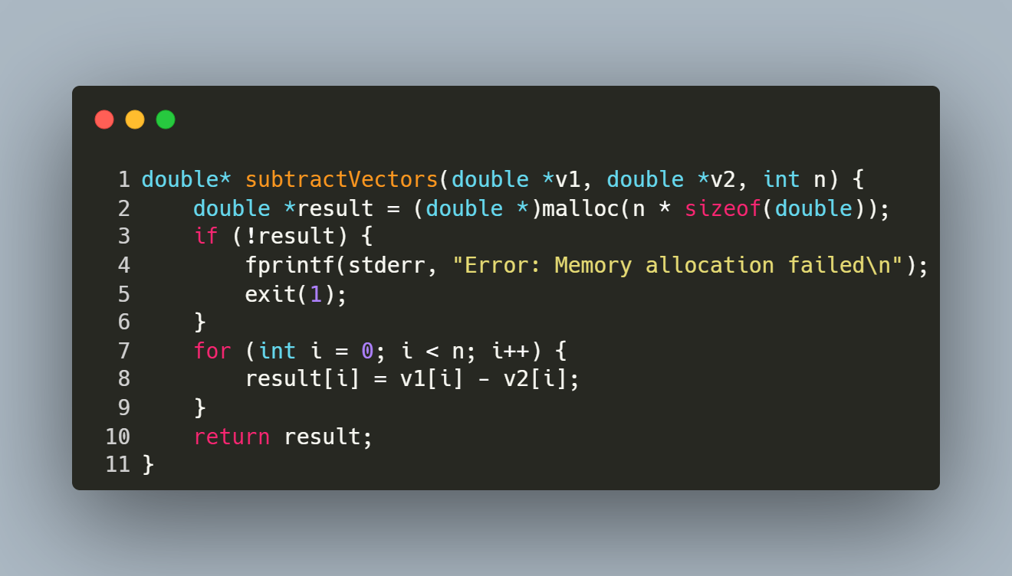
Step-by-Step Explanation
- Memory Allocation:
  - Allocates memory for the result vector result of size n.
  - Exits with an error if memory allocation fails.
- Element-wise Subtraction:
  - Iterates over each index i from 0 to n-1.
  - Computes result[i] = v1[i] - v2[i] for each element.
- Return Result:
  - Returns the vector result containing the difference of v1 and v2.

function: Calculate the square of the Euclidean Norm of a Vector

Purpose: This function computes the square of the Euclidean norm (or magnitude) of a vector.
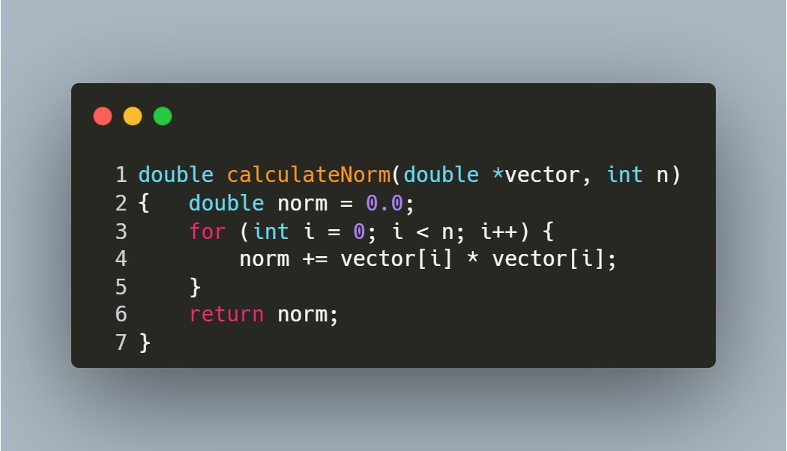
Step-by-Step Explanation
- Initialization:
  - norm is initialized to 0.0 to accumulate the sum of squared elements.
- Element-wise Squaring and Summation:
  - The loop iterates over each index i from 0 to n-1.
  - For each element vector[i], its square (vector[i] * vector[i]) is added to norm.
- Return Result:
The norm is returned:
Norm= $\sum_{i=0}^{n-1}{{V[i]}^{2}}$

Function: Gauss-Seidel

Purpose: This function solves the linear system Ax = b using the Successive Over-Relaxation (SOR) method, an iterative technique that accelerates convergence by introducing a relaxation factor (weight). It is a generalization of the Gauss-Seidel method and is effective for diagonally dominant or symmetric positive-definite matrices.
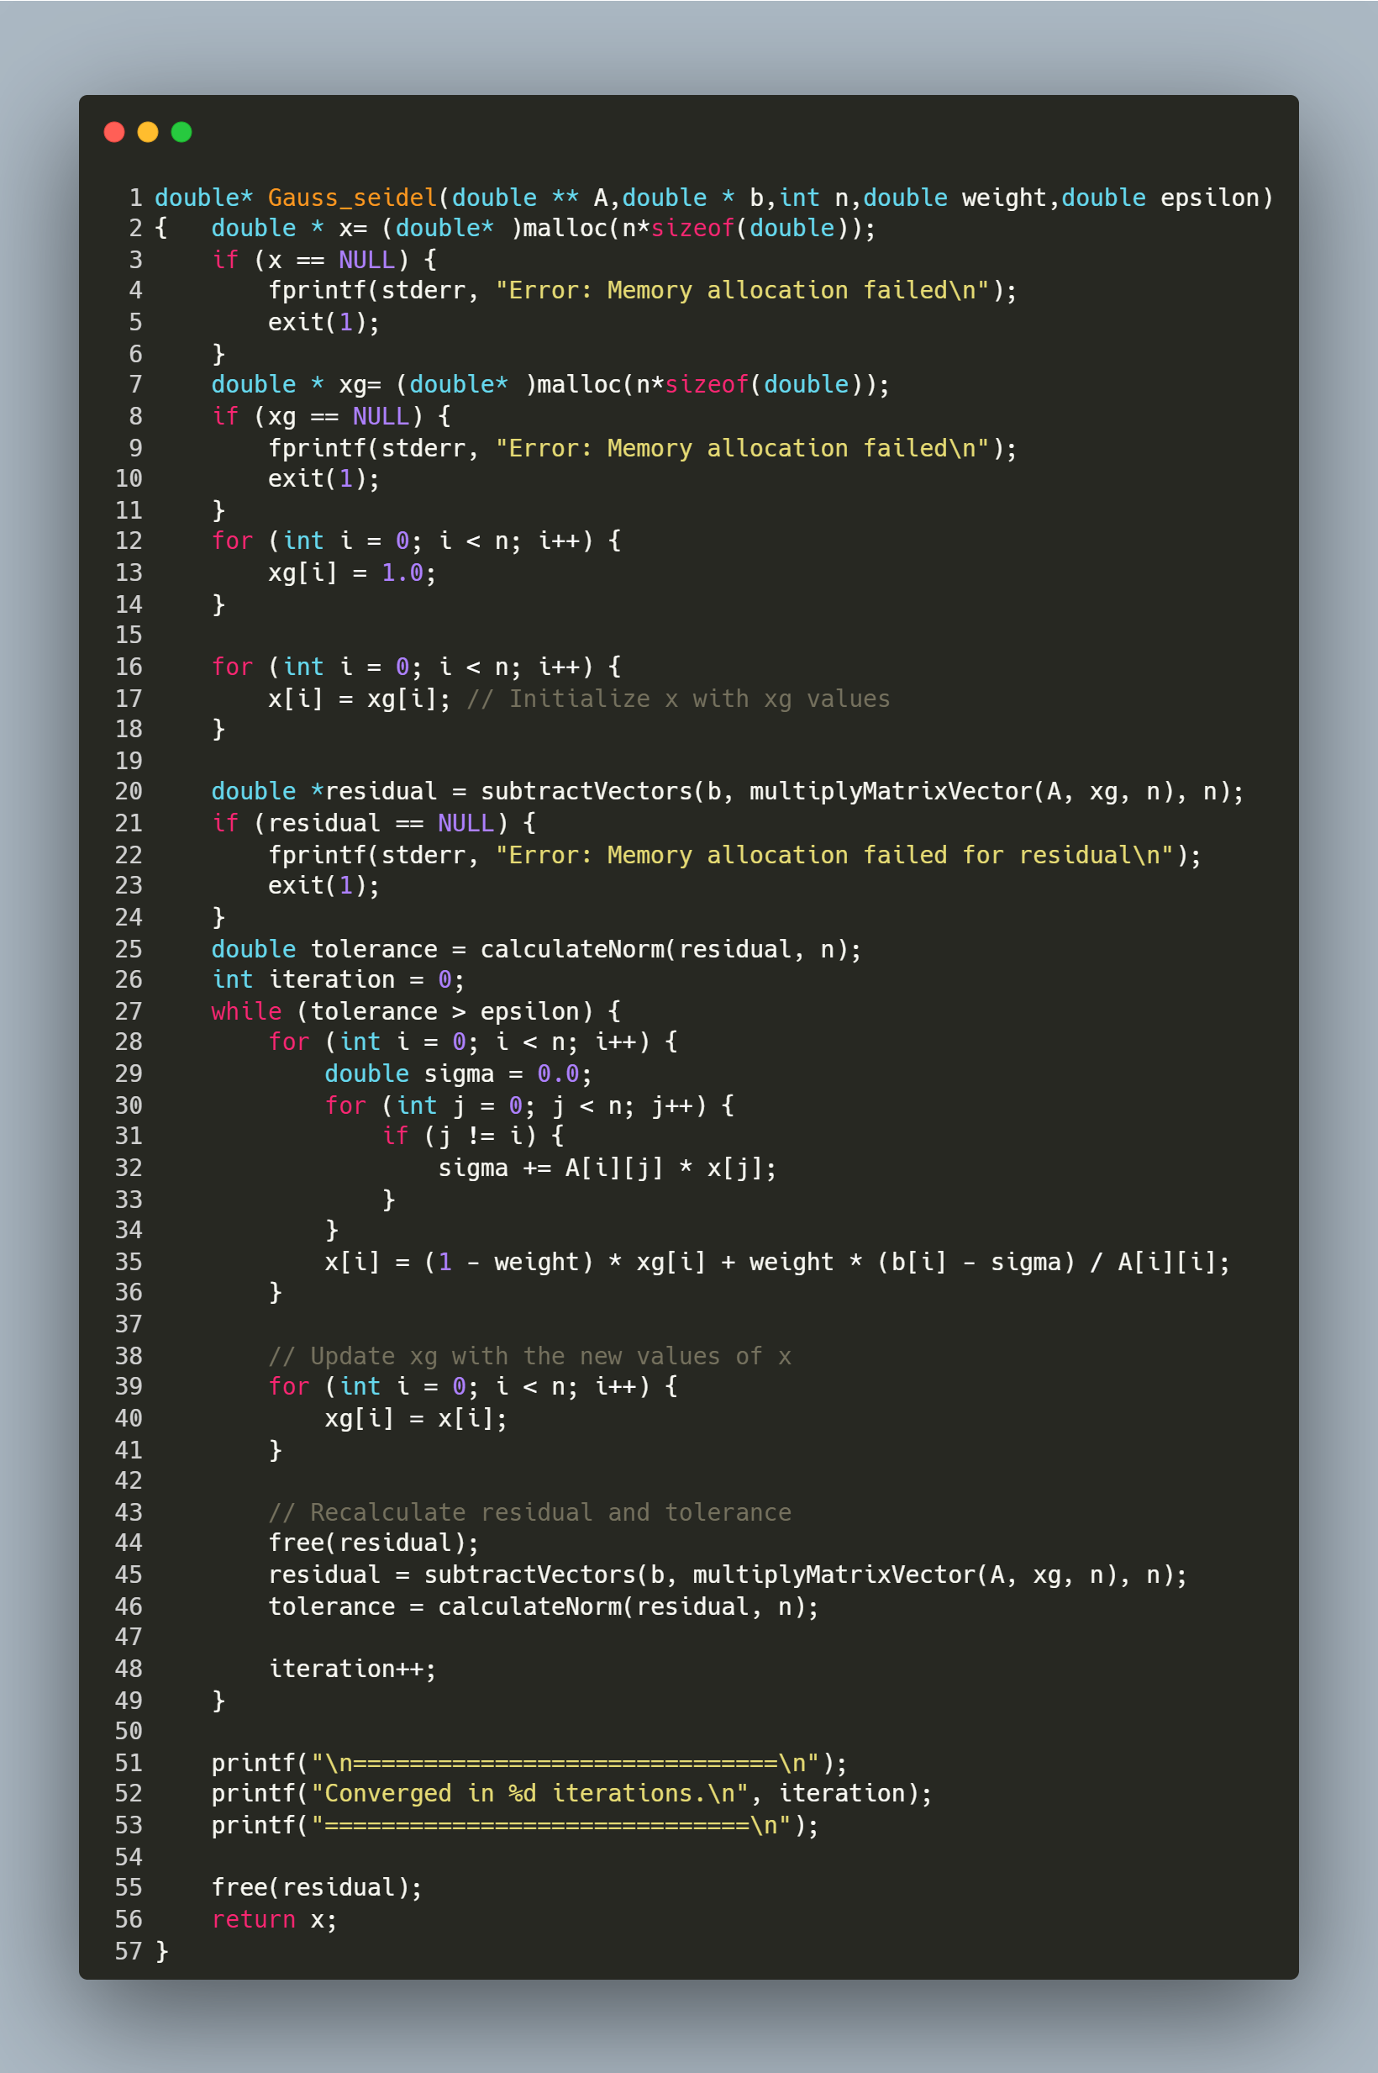

Function Parameters
- A: Coefficient matrix (n x n).
- b: Right-hand side vector (size n).
- n: Size of the system.
- weight: Relaxation factor (1.0 for standard Gauss-Seidel).
- epsilon: Convergence tolerance.
Returns: Solution vector x.
Step-by-Step Explanation
1. Initialization
- Memory Allocation:
  - x: Stores the updated solution in each iteration.
  - xg: Stores the solution from the previous iteration. Initialized to [1.0, 1.0, ..., 1.0].
- Residual Calculation:
c
residual = b - A * xg;
tolerance = ||residual|| (Euclidean norm);
2. Iterative Loop
The loop continues until tolerance ≤ epsilon:
while (tolerance > epsilon) {
// Update each element x[i]
for (int i = 0; i < n; i++) {
sigma = Σ_{j≠i} A[i][j] * x[j];
x[i] = (1 - weight) * xg[i] + weight * (b[i] - sigma) / A[i][i];
}

// Update xg with the new x
xg = x;

// Recompute residual and tolerance
residual = b - A * xg;
tolerance = ||residual||;
iteration++;
}
Key Steps in Each Iteration:
- Element-wise Update:
  - For each element x[i]:
    - Compute sigma, the sum of products of off-diagonal elements of row i and latest x[j] values.
    - Update x[i] using the relaxation formula:
    - $x\left[i\right]=\left(1-ω\right)*x_{old}\left[i\right]+ω*\frac{b\left[i\right]-σ}{A\left[i\right][i]}$
where ω (weight) controls convergence:
      - ω = 1: Standard Gauss-Seidel.
      - ω > 1: Over-relaxation (faster convergence).
      - ω < 1: Under-relaxation (stabilize convergence).
- Update Previous Solution:
  - Copy x into xg to prepare for the next iteration.
- Residual Recalculation:
  - Compute the new residual b - A * xg and its norm to check convergence.
3. Termination and Output
- Convergence: The loop exits when the residual norm tolerance falls below epsilon.
- Result: Prints the number of iterations and returns the solution vector x.

Main Program for Gauss-Seidel with SOR Method

Purpose: This program solves the linear system Ax = b using the Gauss-Seidel method with Successive Over-Relaxation (SOR). It reads the matrix A and vector b from a file, computes the solution x, and prints the results along with performance metrics.
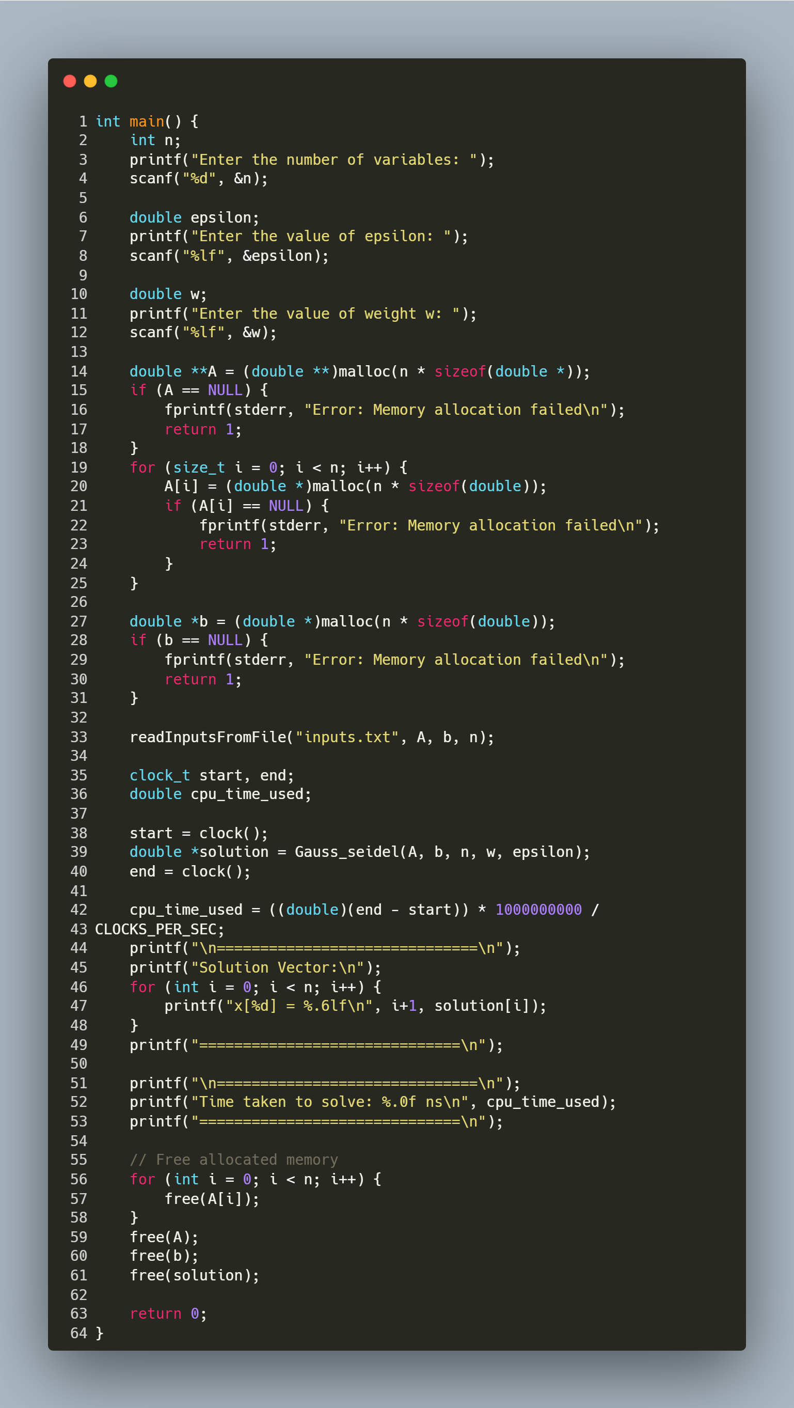
Step-by-Step Explanation
- User Input:
  - Prompts the user for:
    - n: Number of variables (size of the matrix/vector).
    - epsilon: Convergence tolerance (e.g., 1e-6).
    - w: Relaxation factor (1.0 for standard Gauss-Seidel, >1.0 for over-relaxation).
- Memory Allocation:
  - A: Allocates an n x n matrix (dynamic 2D array).
  - b: Allocates a vector of size n.
  - Includes error handling for memory allocation failures.
- Read Input File:
  - Calls readInputsFromFile("inputs.txt", A, b, n) to load A and b from the file.
  - File Format: The file must contain n x n matrix elements followed by n vector elements.
- Solve with Gauss-Seidel SOR:
  - Gauss_seidel(A, b, n, w, epsilon) computes the solution vector x.
    - Input: Matrix A, vector b, size n, relaxation factor w, tolerance epsilon.
    - Output: Solution x and number of iterations to converge (printed internally).
- Performance Timing:
  - Uses clock() to measure CPU time taken by the solver.
  - Converts time to nanoseconds for readability.
- Print Results:
  - Displays the solution vector x with 6 decimal places.
  - Prints the execution time in nanoseconds.
- Memory Cleanup:
  - Frees dynamically allocated memory for A, b, and x to prevent leaks.
- Keynote
  - Timing Function Behavior in Different Environments
    - The program uses the clock() function to measure execution time in CPU cycles and converts it into nanoseconds using CLOCKS_PER_SEC.
- In environments like Windows Subsystem for Linux (WSL) running in VS Code, this function works reliably and provides accurate timing results.
- However, in a terminal-based VS Code setup or native Windows environments, the precision and behavior of clock() may vary due to differences in how CPU time is calculated across platforms.

